**Name: ______________________________ Period: _______________**

**Post-lab for Build an Atom**

1. You build an atom that has the following components:

3 protons

4 neutrons

3 electrons

**Draw a picture of how you would build your atom below:**

**Circle which element this atom is on this periodic table below:**

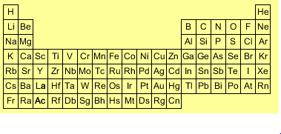

**The mass of this atom is:**

1. 3 mass units **Explain what ideas you used to choose an answer:**
2. 4 mass units ____________________________________________________
3. 6 mass units ____________________________________________________
4. 7 mass units
5. 11 mass units

**The charge of this atom is:**

1. 0, this is a neutral atom
2. -3
3. -1
4. +1
5. +3
6. You start with your atom: 3 protons

4 neutrons

3 electrons

**You want to change your atom’s properties.   
Mark YES if a change will work, and mark NO if it will not work.**

* 1. Hydrogen, Helium, Lithium, Beryllium, Boron, Carbon are all different elements.   
       
     If you want to **change the type of element** your atom is, you can either:

(circle)

Add a proton Yes or No

or Add a neutron Yes or No

or Add an electron Yes or No

Explain the ideas you used to choose your answer:

_____________________________________________________________________  
_____________________________________________________________________

* 1. If you want to **change the charge** of your atom, you can either:

(circle)

Add a proton Yes or No

or Add a neutron Yes or No

or Add an electron Yes or No

Explain the ideas you used to choose your answer:

_____________________________________________________________________  
_____________________________________________________________________

* 1. If you want to **change the mass** of your atom by 1 or more mass units, you can either:

(circle)

Add a proton Yes or No

or Add a neutron Yes or No

or Add an electron Yes or No

Explain the ideas you used to choose your answer:

_____________________________________________________________________  
_____________________________________________________________________

* 1. If you **add 1 proton and 1 neutron to your atom** …

Will the element change? ____ If so, circle the new element?



Will the mass change? _____ If so, what is the new mass of the atom? ________  
Will the charge change? ____ If so, what is the new charge of the atom?________